**Internship Assignment Report: Cyber Security and Digital Forensics**

**Assignment 9: Nmap**

* **TryHackMe Rooms:**
  + nmap01
  + furthernmap

**Assignment Overview**

* Welcome to my internship assignment report! This document highlights the cybersecurity and digital forensics challenges I've tackled as part of my Cyber Security and Digital Forensics internship with **CyberSecured India**. The focus of this report is on Nmap, and it includes practical exercises completed on **TryHackMe**.
* Through these assignments, I've had the opportunity to apply theoretical knowledge in real-world scenarios, hone my problem-solving skills, and gain hands-on experience with essential cybersecurity concepts. Each section will walk you through the tasks I've completed, showcasing the steps I took, the tools I used, and the insights I gained along the way.

#### ****Background and Prior Experience****

Before starting this internship, I had already completed several rooms on TryHackMe and HackTheBox. This prior experience gave me a solid foundation in cybersecurity principles and practical skills. During the internship, I continued to build on this knowledge by tackling new challenges and applying what I had previously learned in more complex scenarios.

**About Me**

* **Name:** Yugander Chanupalli
* **Position:** Cyber Security and Digital Forensics
* **Organization:** CyberSecured India
* **Email:** yugander9010@gmail.com
* **Submission Date:** 09/10/2024

**TryHackMe**

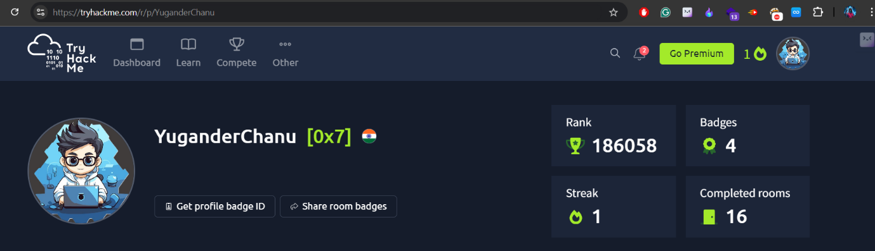**TryHackMe Account Picture:**

**Nmap**

**Overview:**

In the "Nmap" room on TryHackMe, I got hands-on experience with tools and techniques used to gather information about targets without making direct contact. This room was all about exploring how to use command-line tools and publicly available services to scan targets. What’s cool is that these tools can provide a massive amount of information once you know how to use them and interpret the results effectively.

**Proof of concept:**

Nmap Live Host Discovery:

I understood the concept by completing using the publicly available tools. Below image demonstrates the using of Nmap to scan live targets.

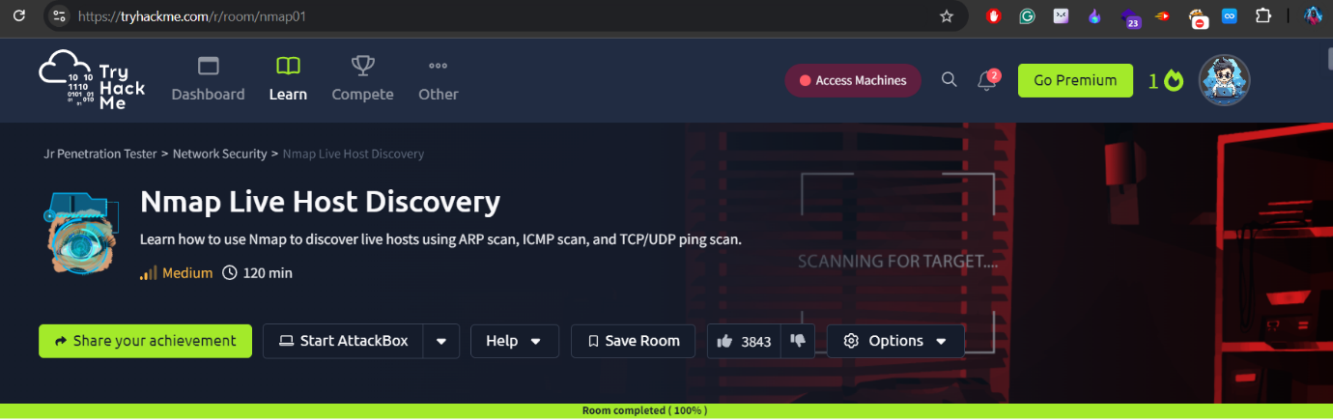

Nmap:

This lab covers all the information that is related to penetration tester. With this details we can easily scan the network.

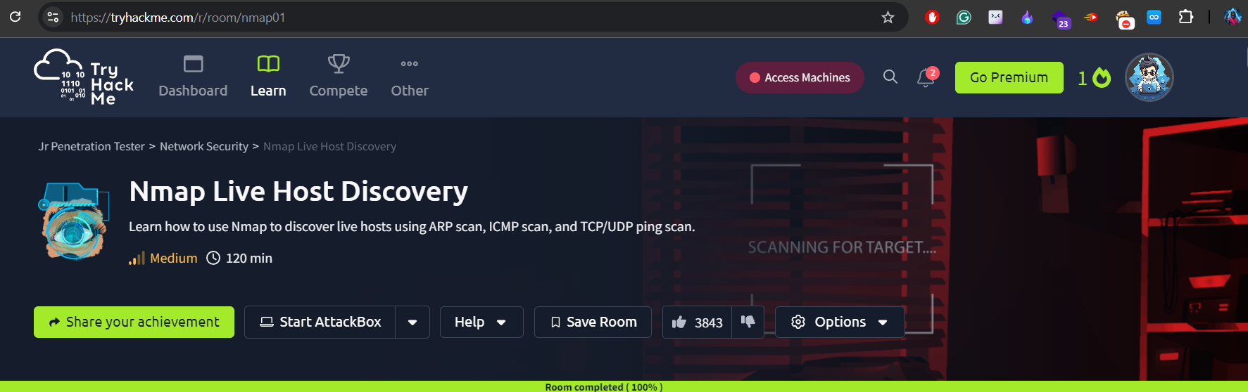

Finally, completed the all tasks that are related to this room helped me to understand the use of reconnaissance importance.